Notice Of Deposit

- Purpose

When the customer fails to settle his account after the Second Notice, the CI/Collector or the Cashier will encode the Notice for Deposit and send a copy to the customer.

- Views
  - List View
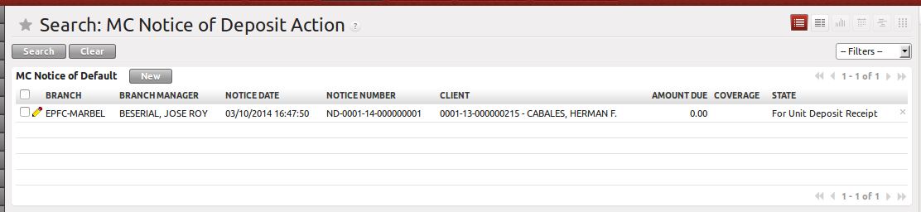
Figure 1. List view of Unit Deposit Receipt

  - Form View
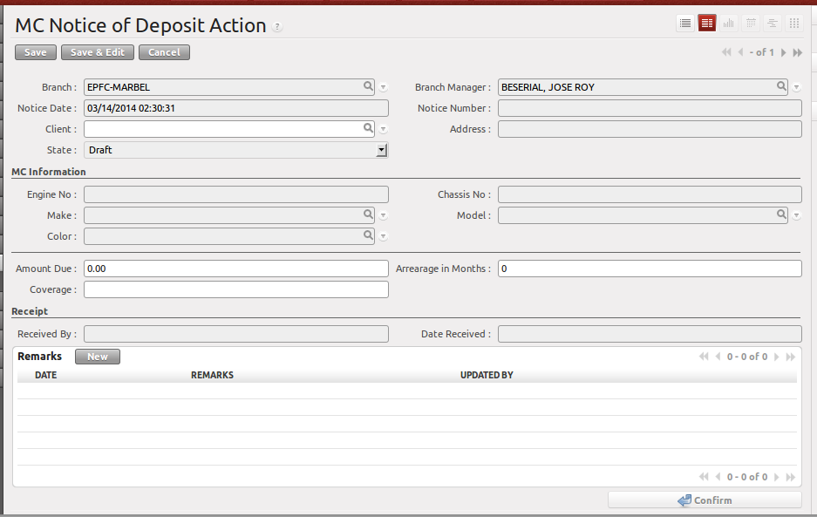
Figure 2. Form view of Unit Deposit Receipt

- Menu and Access Rights
  - Menu – Loan > MC Deposit > Notice Of Deposit
  - Access Rights
Role | Read | Write | Create | Delete
CI/Collector | Yes | Yes | Yes | No
Branch Manager | Yes | Yes | Yes | No
Receptionist | Yes | Yes | No | No

- Required Fields
All required fields can be easily distinguished from the form view. These are the fields highlighted in Figure 2.

- Client – name of the client, use the lookup function to set this

- Workflow
Below is the list of states and visibility of the various buttons based on the record state:

State | Description | Visible Buttons
Draft | Initial state of the NOD record | Confirm
Confirm | Confirms the NOD record | Unit Deposit Receipt

- User Action
Below is the list of user action available for specific users and its corresponding procedures:

Button | Action | Triggered By
Confirm | - Fields are non-editable except Received By and Receive Date | CI/Collector
Unit Deposit Receipt | - Creates a new record to Loan > MC Deposit > Unit Deposit Receipt  - Set state to “For Unit Deposit Receipt” | CI/Collector

- Field Visibility
Below is the list of fields and their accessibility based on the record state:

Field | Description | Editable States
Client | Select from List | Draft
Amount Due | Defaulted amount | Draft
Arrearage in Month | Number of months account is not paid. | Draft
Coverage |  | Draft
Remarks | Will be updated by the CI/Collector of what is the status of the NOD specially after they follow-up the customer or deliver the NOD to customer | Draft  Confirm  Received  For UDR
Received By | Name of the person who received the NOD. If filled up together with Date Received, the status of the record will be set to “Received” | Confirm
Date Received | Date of Receipt. If filled up together with Date Received, the status of the record will be set to “Received” | Confirm

- Reports and Print Outs

